Chapter 17
Leaf Spots
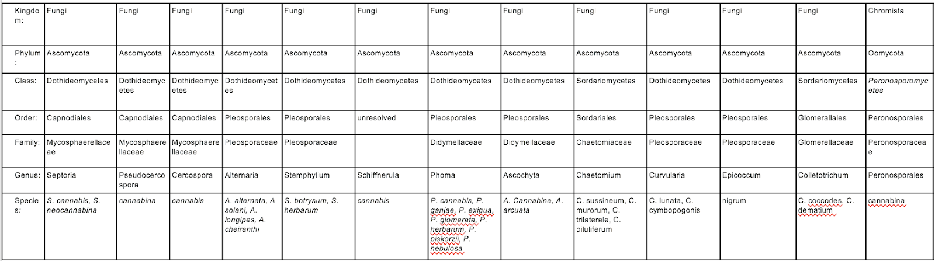

Leaf spot is another general term that is used to characterize numerous diseases caused by a plethora of different bacteria or fungi. As the name suggests, this is a disease that manifests itself on the leaves of plants and appears as a chlorotic spot that eventually dies (necrosis) (Fig. 1). Oftentimes, growers can confuse these infections with nutrient deficiencies. Although not typically as devastating as other fungal pathogens, leaf spots are going to decrease photosynthesis, thereby decreasing sugar production and resulting in poor plant growth and less than optimal yields.
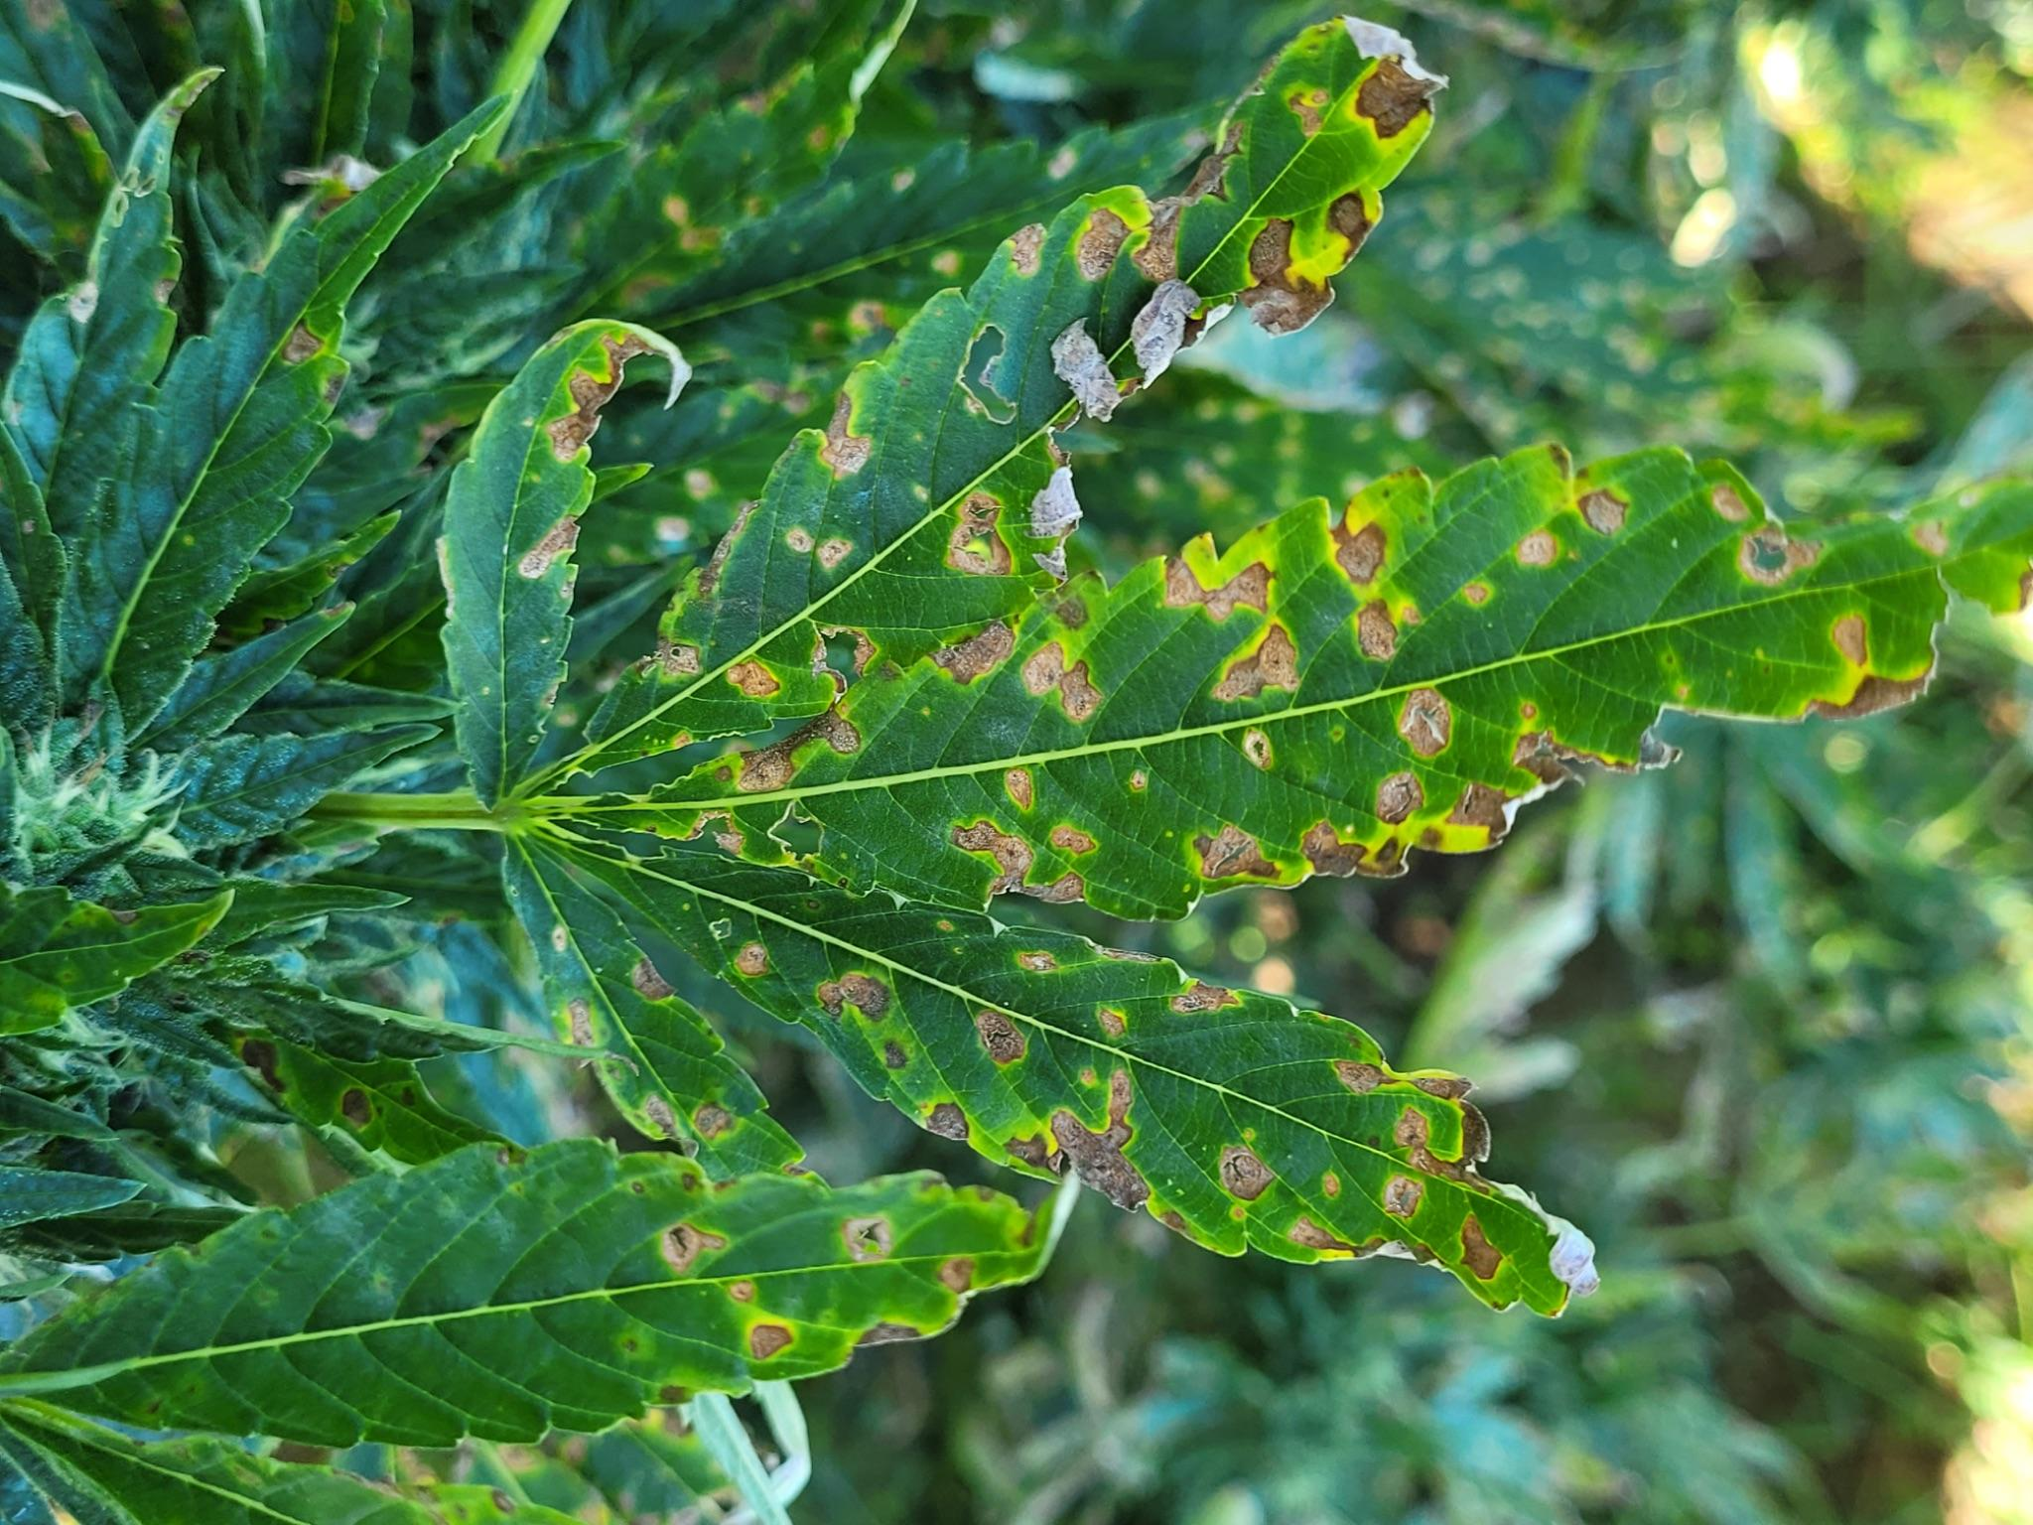
Figure 17.1 Septoria causing leaf spot symptoms on flowering hemp plants. Photo by Dr. Nicole Gauthier.

Some of the fungi that can lead to leaf spots are listed above. Note that all of the ‘true fungi’ in this group are Ascomycetes. The symptoms of leaf spots are generally the similar; irregular or regular botches on the foliage of various plants (Fig 1). In some cases, this can eventually lead to overall defoliation if left untreated.
Typically the features of leaf spots caused by pathogens are distinct from nutrient deficiencies. One common feature of many pathogen-induced leaf spots is the presence of a halo of necrotic tissue around pathogen infected tissue. This represents the host plant’s attempt to wall off the pathogen from living tissue by killing plant cells surrounding the infection in a systemic acquired resistance (SAR) induced hypersensitive response.
Biology
Spores from casual fungi land on susceptible plant surfaces, germinate, and form an appresoria with which they penetrate the plant surface to gain access to internal plant tissue. Leaf spot organisms cause localized infections. Some may exist as asymptomatic endophytes for a period of time or under certain conditions before causing disease. For instance, Alternaria is commonly isolated as an endophyte from a broad variety of host plants, including Cannabis, though it is also recognized as a leaf spot pathogen (Taghinasab and Jabaji 2020).
Nearly all fungi which cause leaf spots either reproduce exclusively via asexual conidiospores (Cercospora, Pseudocercospora, Alternaria), or primarily so (Septoria). Because of this, secondary disease cycles can rapidly progress within a single season from a small initial inoculum source. Septoria also may form sexual fruiting structures (perithecia), persisting overwinter on crop debris where it forms sexual fruiting bodies and disseminates via ascospores the next season (O’Connell et al. 2005).

Prevention and Treatment
Ensuring plants are healthy, vigorous, and pathogen free from the start is important for
avoiding leaf spot diseases. Proper plant nutrition will reduce disease occurrence and severity; nitrogen deficiencies are associated with leaf spot. Because leaf spot organisms survive on crop debris through the off-season, removing diseased crop residue and encouraging high saprophytic activity in the soil can reduce inoculum load and survival.
All of the pesticide applications used for powdery mildew can be utilized against leaf spot fungi (Table 11.1). Foliar applications of compost teas or other microbial inocula throughout the vegetative growth phase may also reduce leaf spot occurrence. Kumar et al. found that in competition studies Trichoderma harzianum, T. viride, and T. virens all were able to outgrow leaf spot causing fungus Alternaria alternata (Srivastava et al 2012). The same study showed that of the three Trichoderma species tested, T. viride was able to directly parasitize and lyse the hyphae of the pathogen (Srivastava et al 2012).
Breeding resistant cultivars may be the most economical and ecologically feasible way to develop plants that are more resistant to certain fungal pathogens (Danon et al. 1982). However, developing resistant varieties to leaf spot fungi will only be adventitious if the resistance offers broad protection against the large range of fungi capable of causing leaf disease, or in areas where specific pathogen species causing significant losses may be targeted in a breeding program.
Interestingly, Indian researchers found that by creating a 1:1 water extraction with dried Cannabis leaves and mixing the solution with a prepared nutrient agar, this inhibited the growth of A. alternata in vitro (Kumar et al. 2015). This could potentially be a simple solution for leaf spot fungi farmers generally and warrants further investigation.

In summary:

- Leaf spot is another disease named after the plant symptoms that is caused by a number of different organisms, typically bacteria or fungi
- Growing/breeding plants resistant to leaf spot organisms and clean cultural practices can alleviate pressure from these pathogens
- Organic fungicides and biocontrol agents can be used if the disease is severe

